NAME: ALUWALA SHARANYA

HT NO: 2403A52013

ASSIGNMENT:23

BATCH:02

Task 1 – Project Proposal

* Students choose a real-world problem to solve with an AI-assisted application (e.g., ecommerce billing system, health monitoring dashboard, student attendance tracker).
* Prepare a project proposal including: oObjective
  + Features
  + Tools/technologies to be used

PROMPT: Develop a code to generate a python code Project Proposal • Students choose a real-world problem to solve with an AI-assisted application (e.g., ecommerce billing system, health monitoring dashboard, student attendance tracker). • Prepare a project proposal include

Expected output:

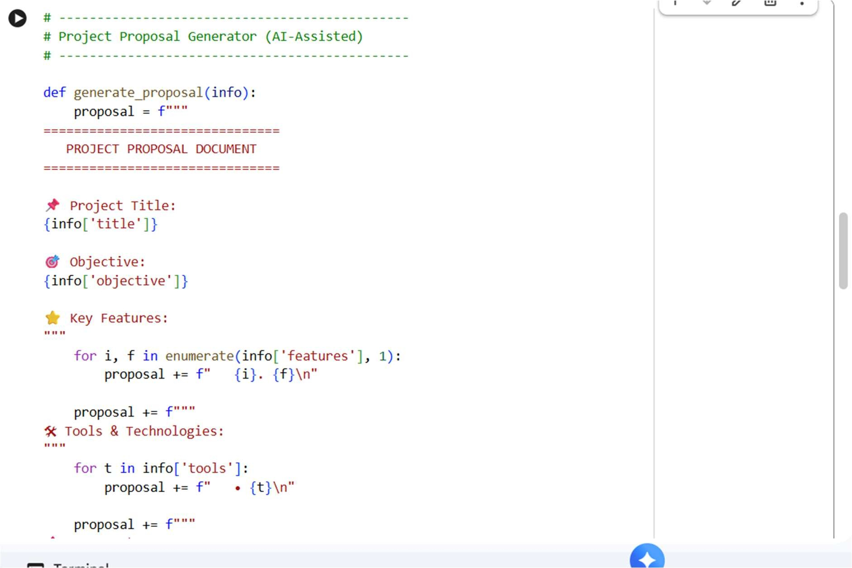

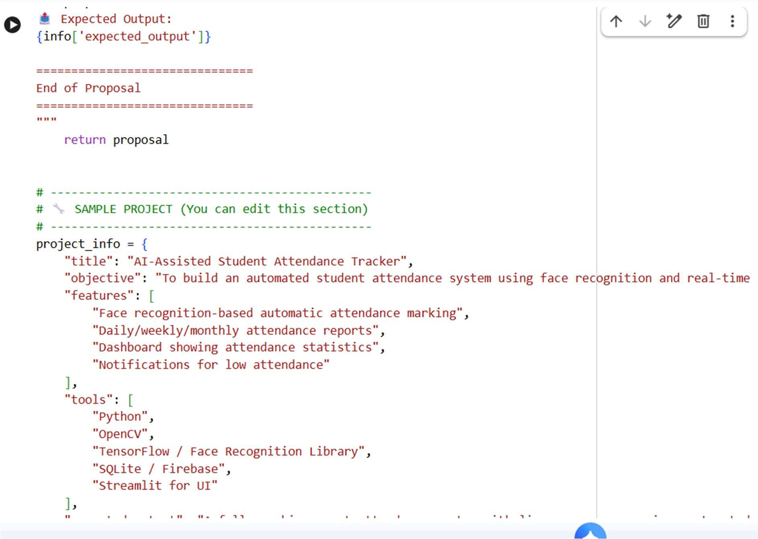

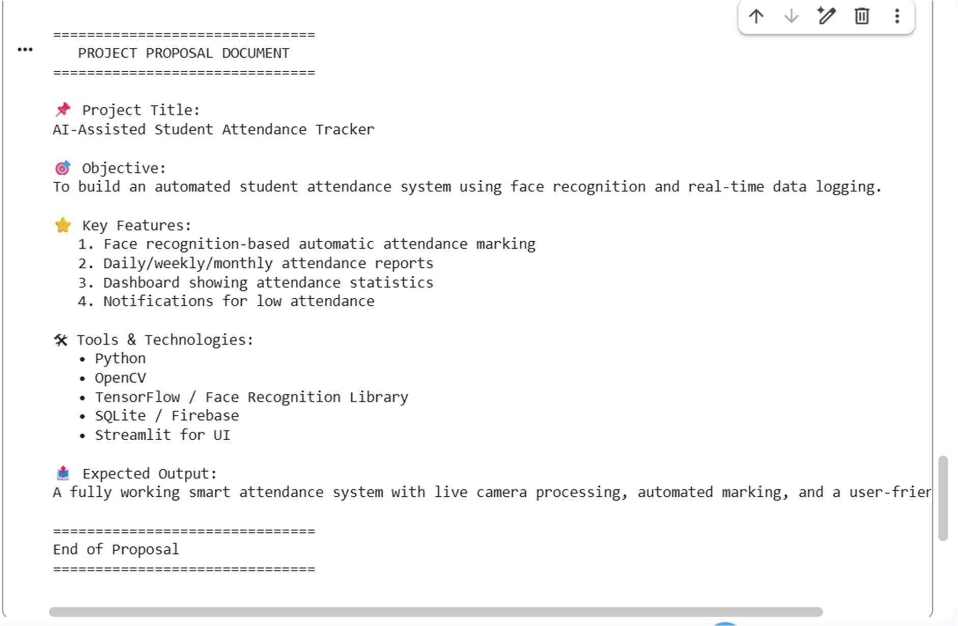

Task 2 – Application Design •Use AI tools to assist in: oDesigning system architecture diagrams. oDefining database schema (if needed).

Creating wireframes/UI mockups for frontend design PROMPT:

Generate a python code to develop an Application DesignUse AI tools to assist in: o Designing system architecture diagrams. o Defining database schema (if needed). o Creating wireframes/UI mockups for frontend design Expected output:

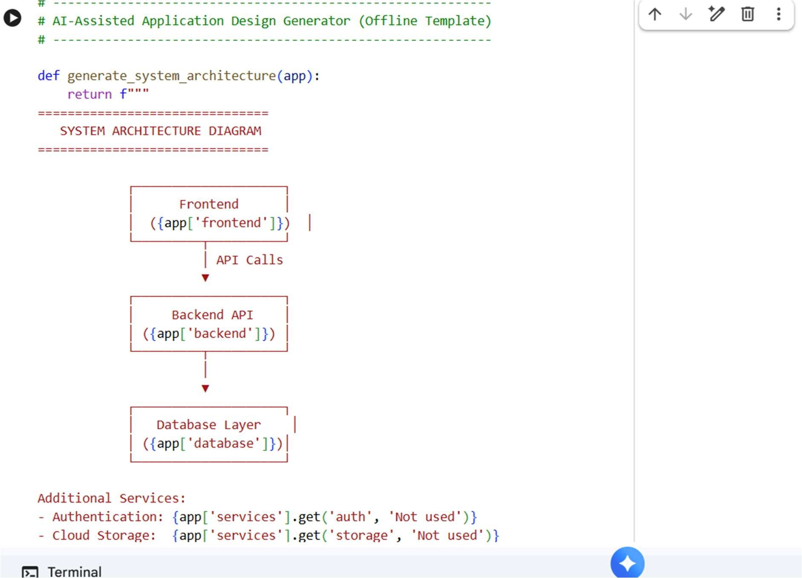

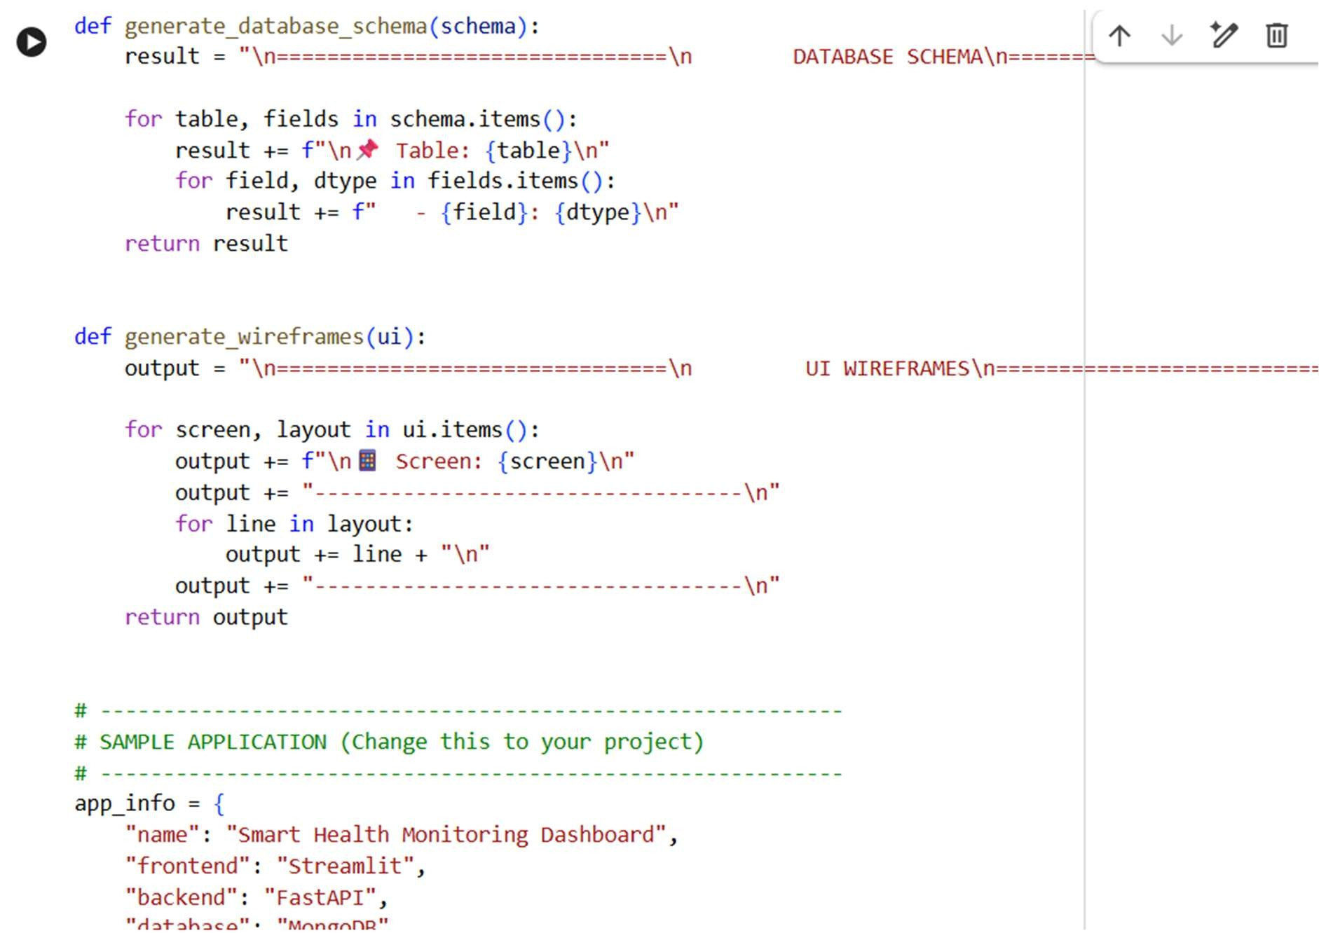

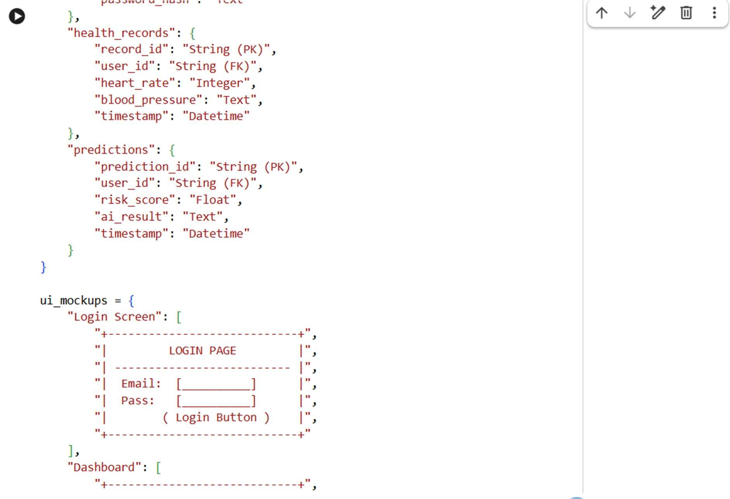

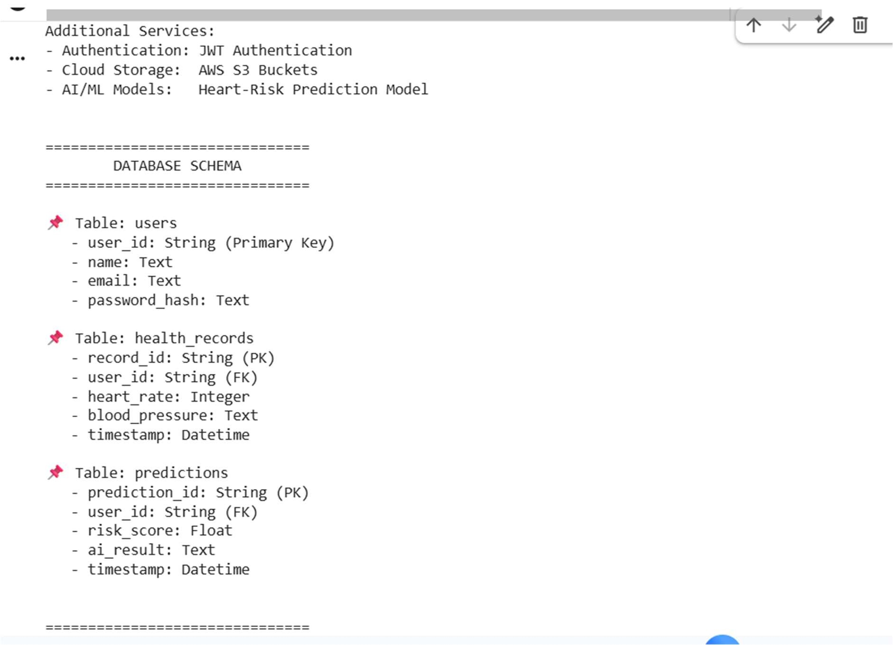

Task 3 – AI-Assisted Code Development

•Implement the application in phases:

* Frontend: Web/mobile UI with HTML/CSS/JS (or framework).
* Backend: RESTful APIs or server logic.
* Database: Schema design, SQL queries.

Integration: API calls, authentication, error handling PROMPT:

Develop a code generate a python code AI-Assisted Code Development • Implement the application in phases: o

Frontend: Web/mobile UI with

HTML/CSS/JS (or framework). o Backend: RESTful APIs or server logic. o Database: Schema design, SQL queries. o Integration: API calls, authentication, error handling

Expected output:

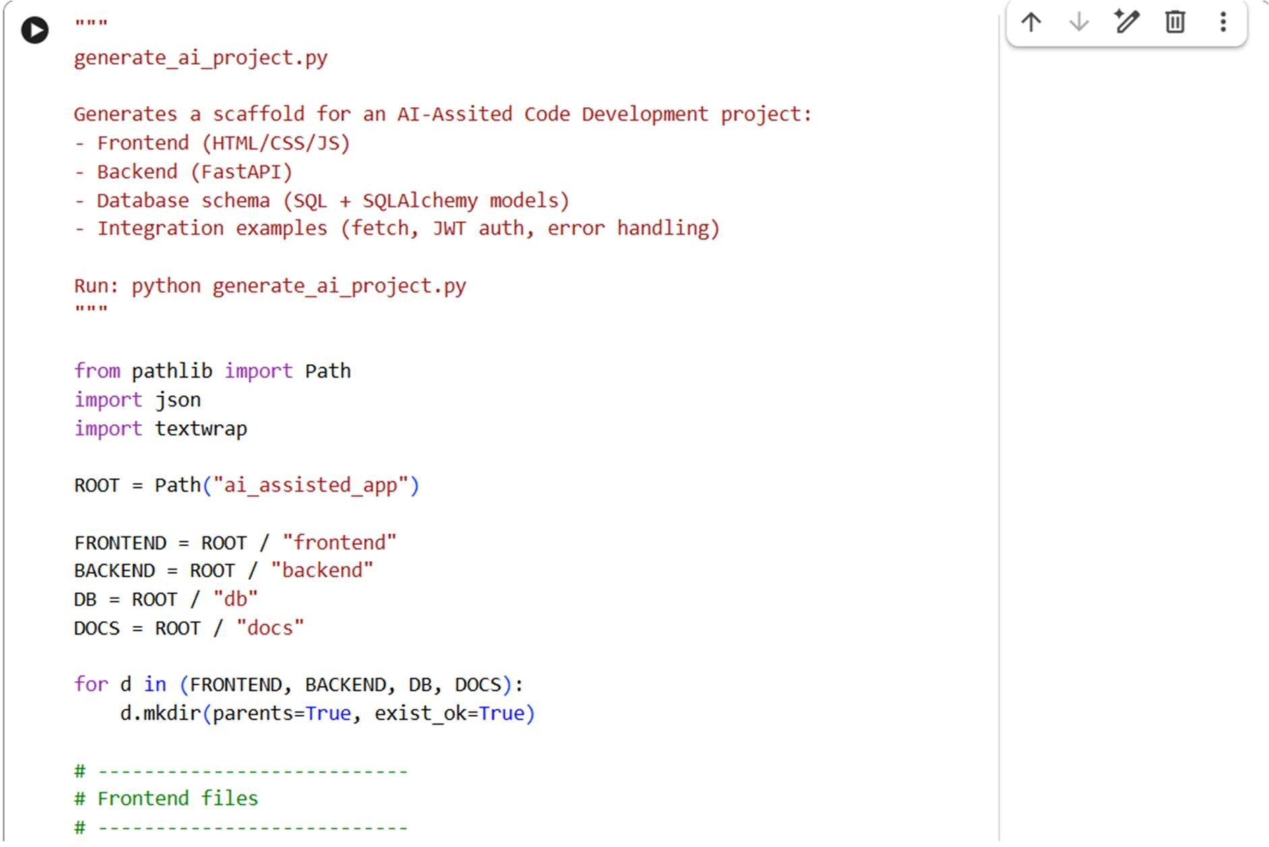

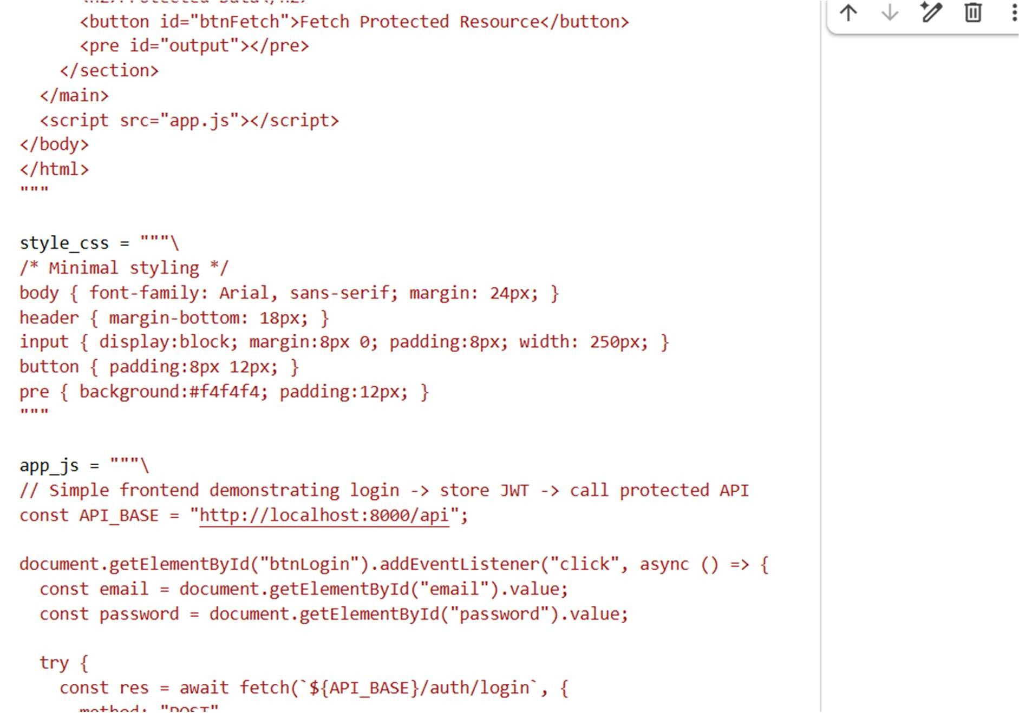

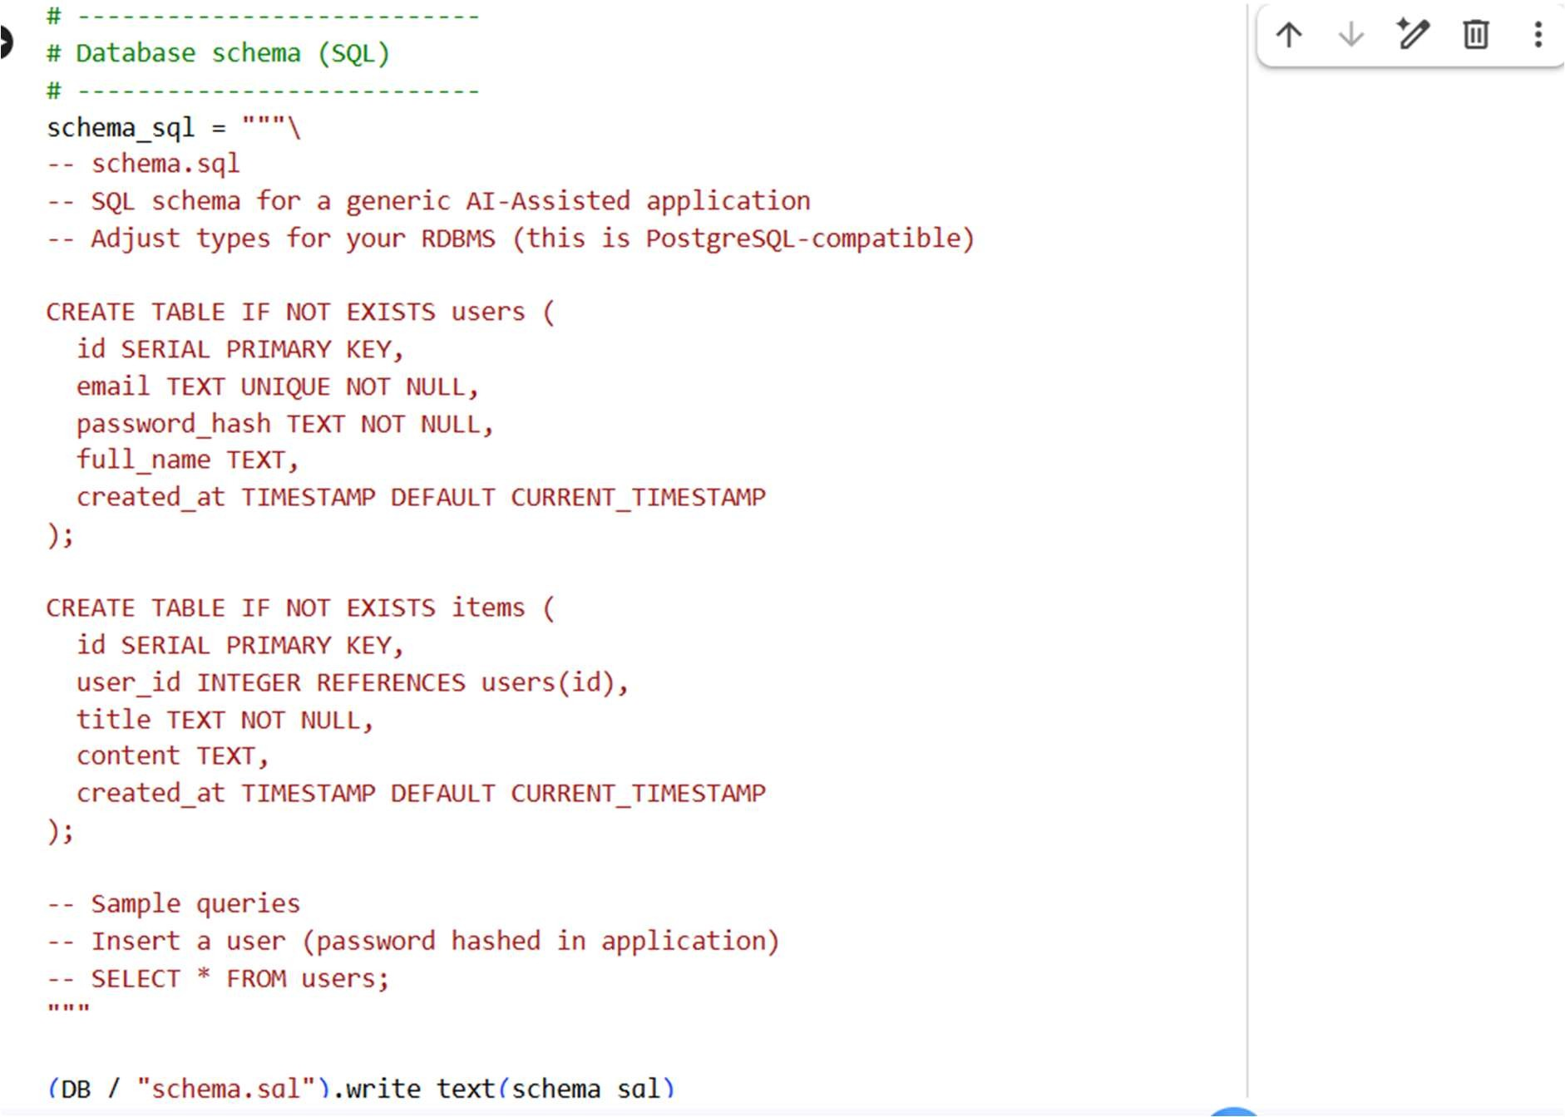

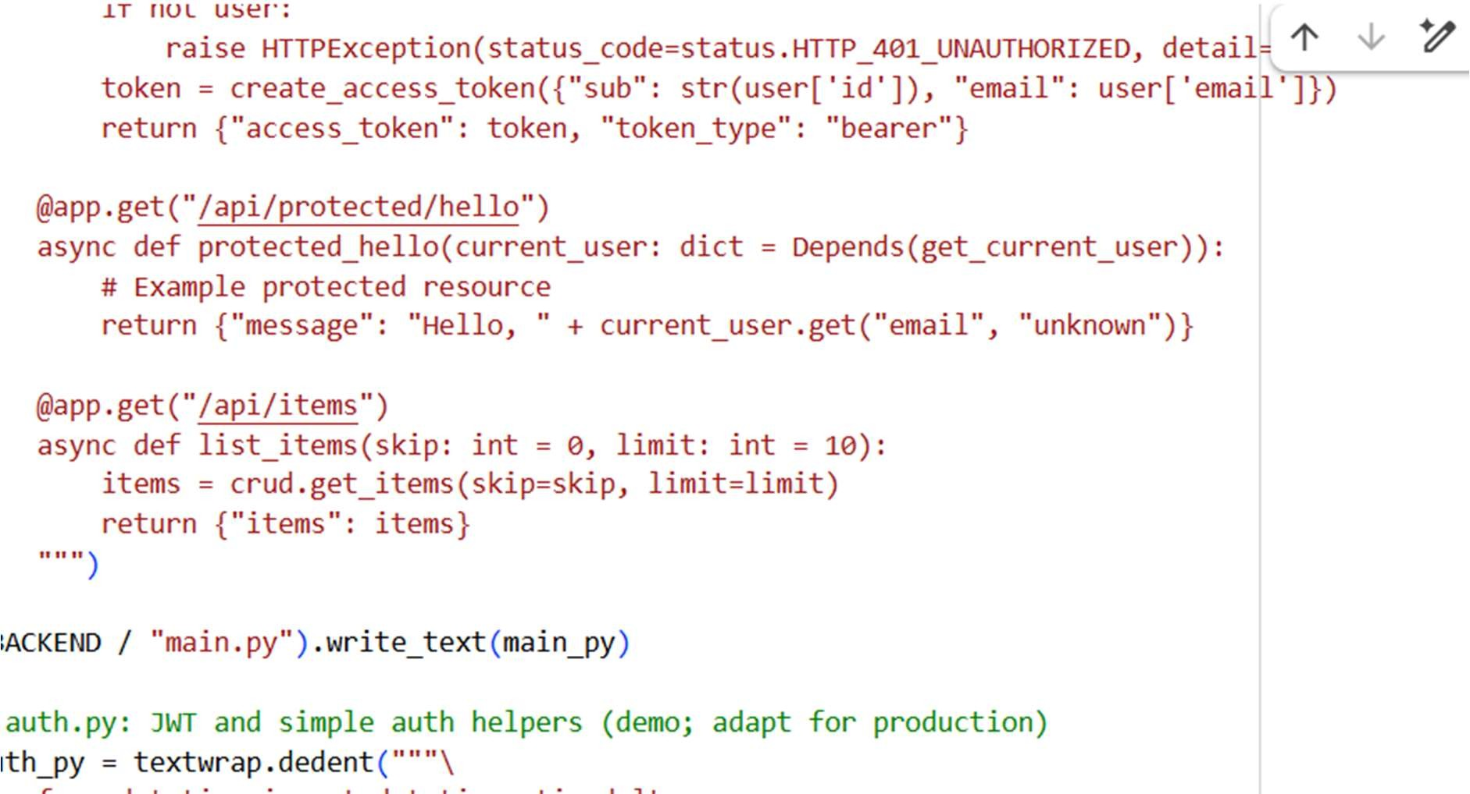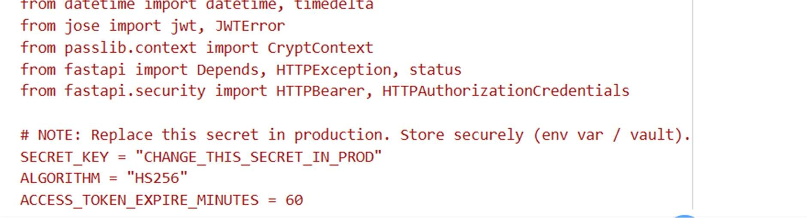

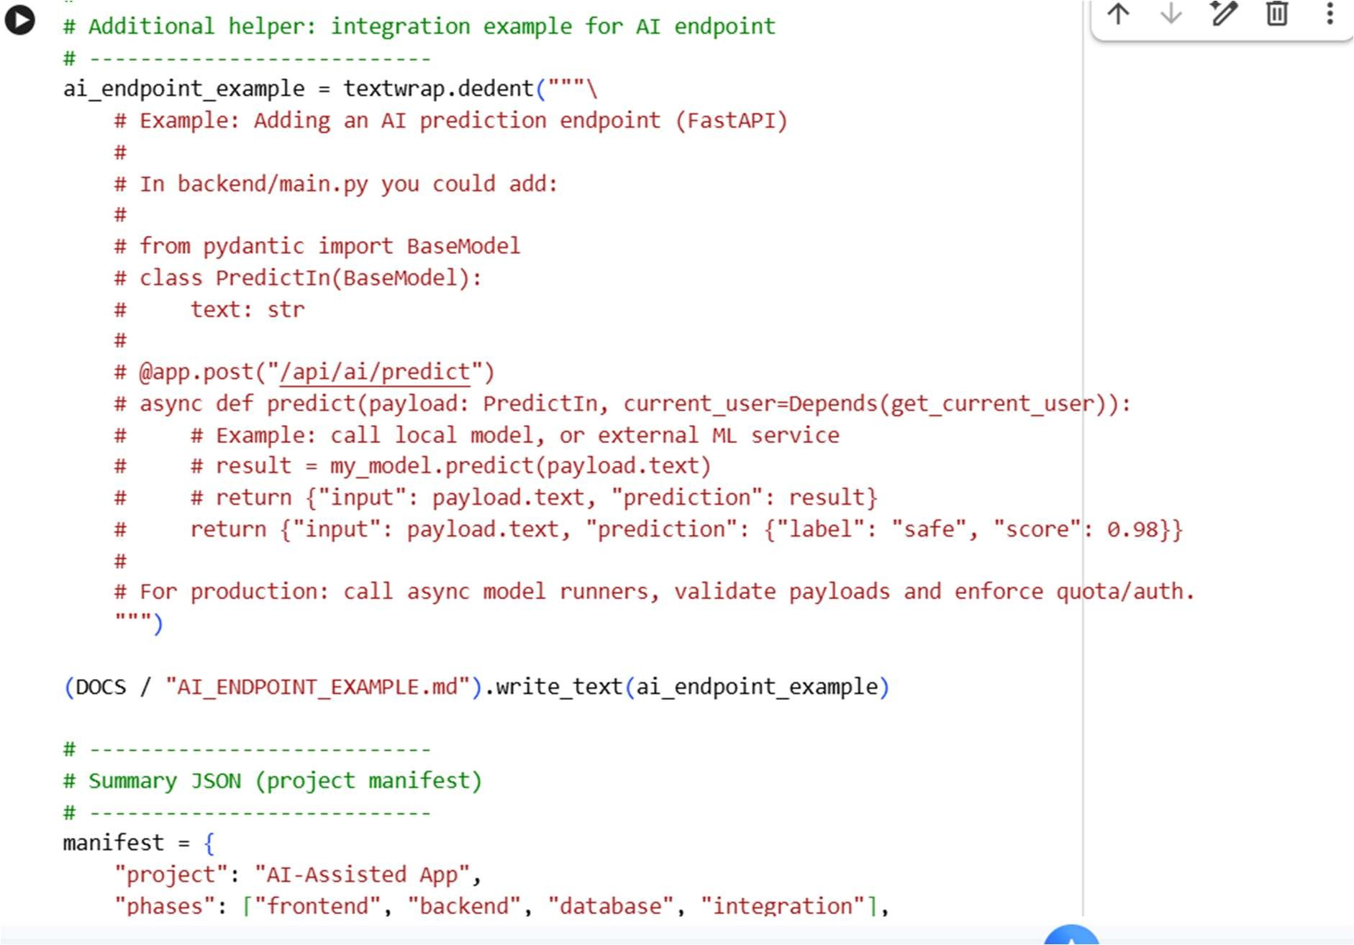

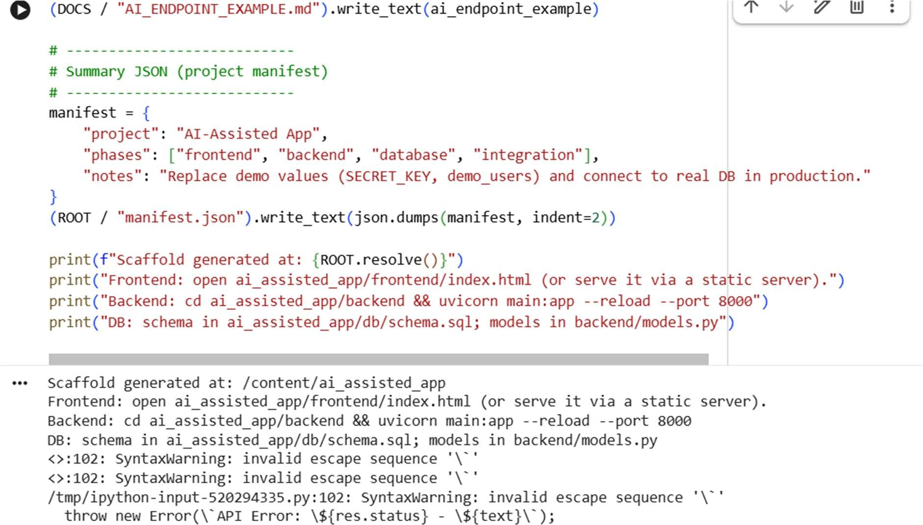

Task 5 – Testing & Debugging • Use AI to: o Generate unit tests. o Identify vulnerabilities/security flaws. o Suggest optimizations for performance PROMPT:

Develop a python code to generate Use AI to: o Generate unit tests. o Identify vulnerabilities/security flaws. o Suggest optimizations for performance Expected output:

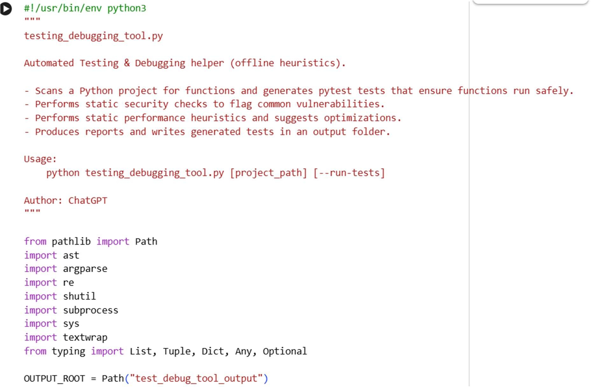

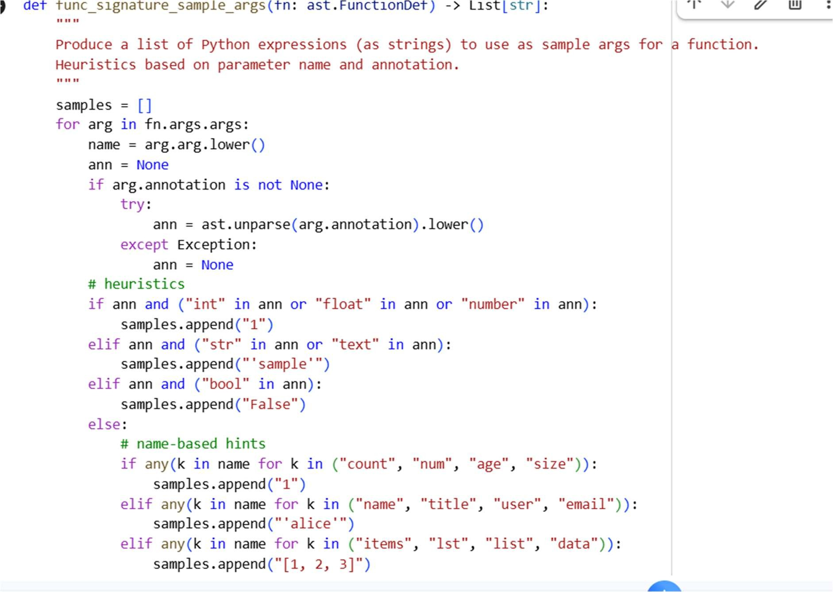

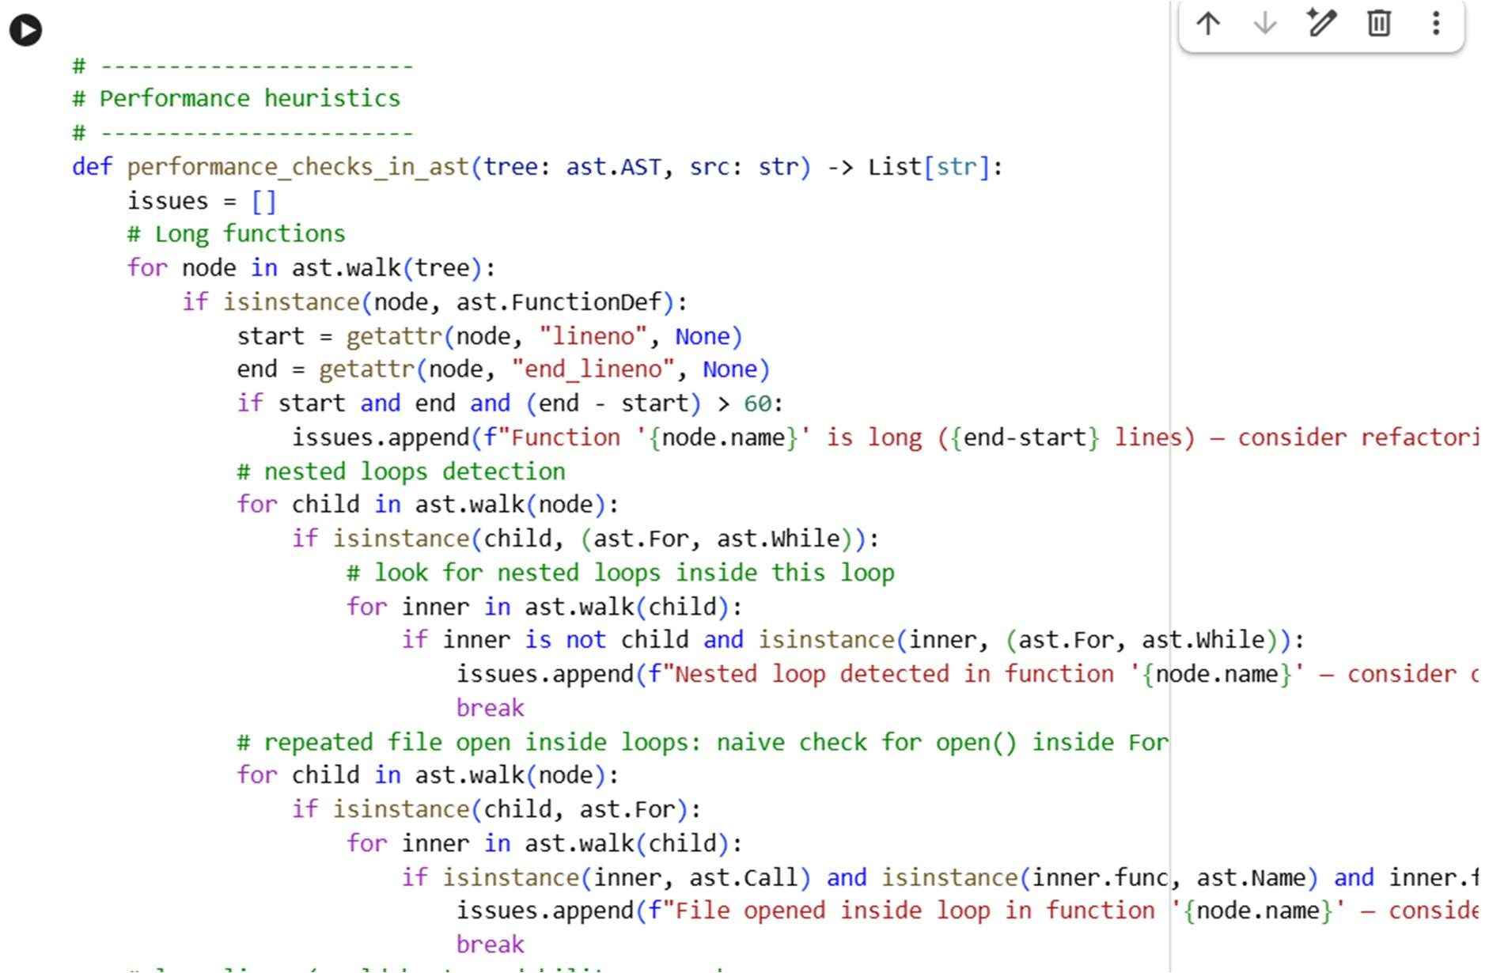

Task 6 – Deployment & Presentation

* Deploy application on a cloud/free hosting platform (Heroku, GitHub Pages, Firebase, etc.).
* Prepare a final presentation including: oProblem statement
  + Solution architecture
  + Live demo
  + Reflection on AI assistance and

limitations

Expected Outcomes:

* A complete, deployable software application.
* Students gain experience in end-toend development with AI tools.
* Improved skills in teamwork, documentation, and ethical AI usage.

脥 Deliverables (For All Tasks)

1. AI-generated prompts for code and test case generation.
2. At least 3 assert test cases for each task.
3. AI-generated initial code and execution screenshots.
4. Analysis of whether code passes all tests.
5. Improved final version with inline comments and explanation.
6. Compiled report (Word/PDF) with prompts, test cases, assertions, code, and output.

PROMPT:

generate a python code to develop an Deployment & Presentation • Deploy application on a cloud/free hosting platform (Heroku, GitHub Pages, Firebase, etc.). • Prepare a final presentation including: o Problem statement o Solution architecture o Live demo o Reflection on AI assistance and limitations

Expected output:

